**Task 2&3**

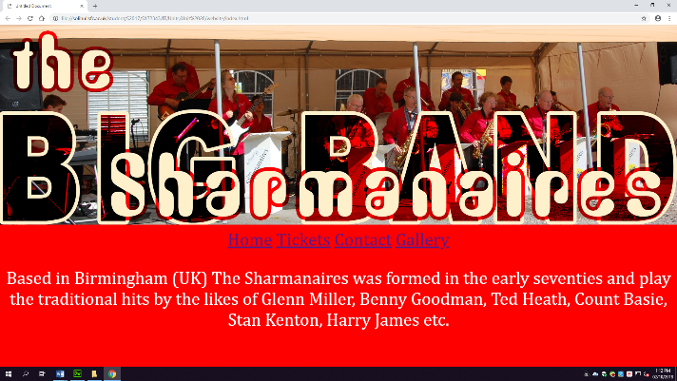Webpages:

This is my home page with the navigation at the top and information about the band, allowing people to jump from page to page.

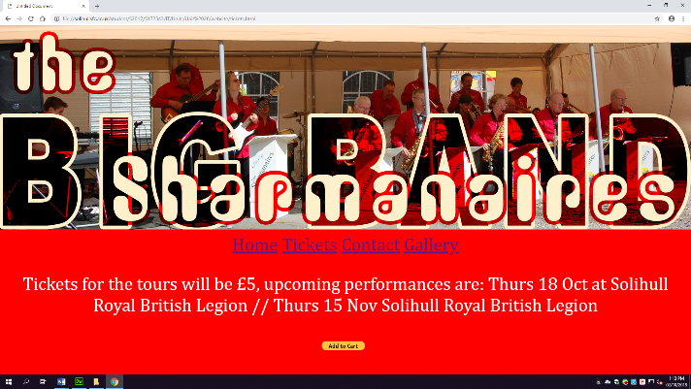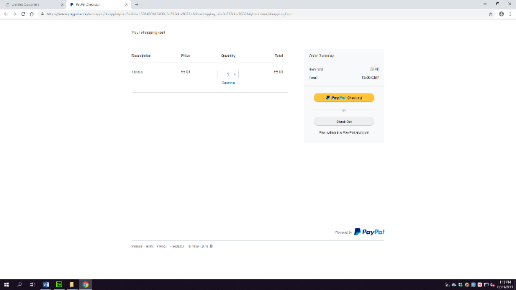 These pages are my purchasing pages with the first one giving information on the ticket prices and the second being the shopping cart through the PayPal code.

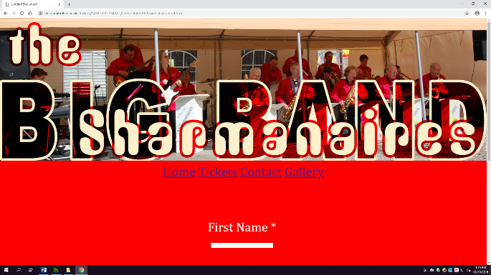

This page is my contact page, allowing people to input their contact details and a query in order to get a response from the band.

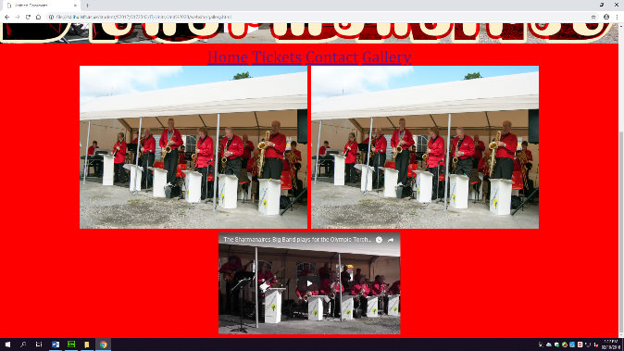This is my gallery page of which has two images and one embedded video allowing the user to see images of previous performances and a video through embedding the code from their YouTube channel.

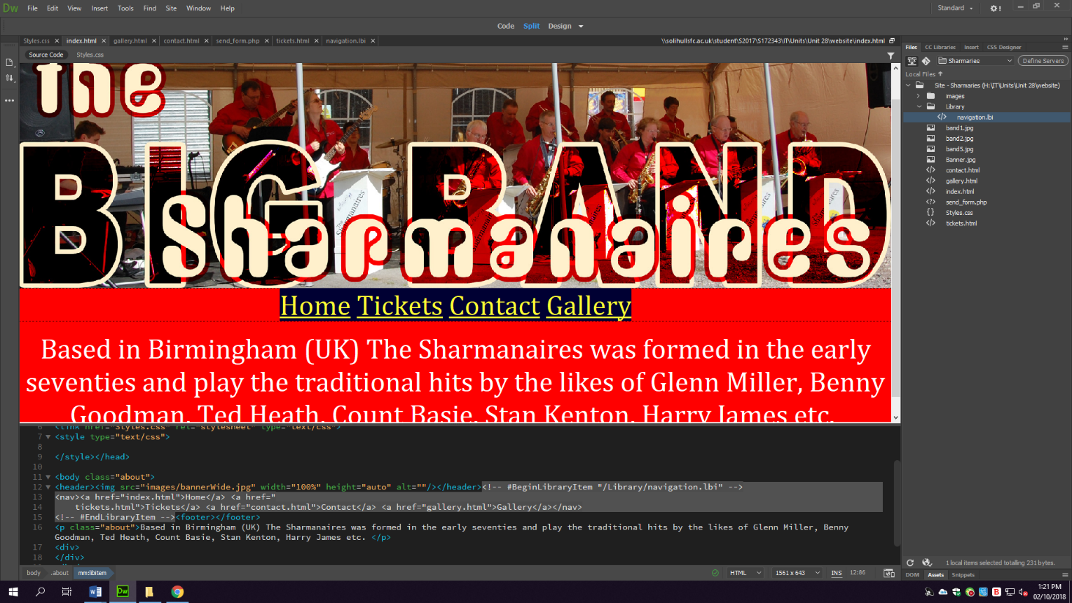Navigation:

For the navigation, I have set the four pages together using a library item – displayed at the top right of the page – which allowed me to type “../Index” or whatever the page name was to link them together through this item, this then allowed me to insert the library item onto every page which then set the navigation across all pages. The navigation displayed in the header of every page, allowing the user to clearly see each of the titles for them to select as a result of the definition within my navigation library item to link them all together. A library item is a way to store items or pages within one location within your code, this way I could edit and update every page at once as opposed to editing each one individually, I chose to use this method over alternatives due to that fact that it was the easiest and most convenient way to input my navigation into my website.

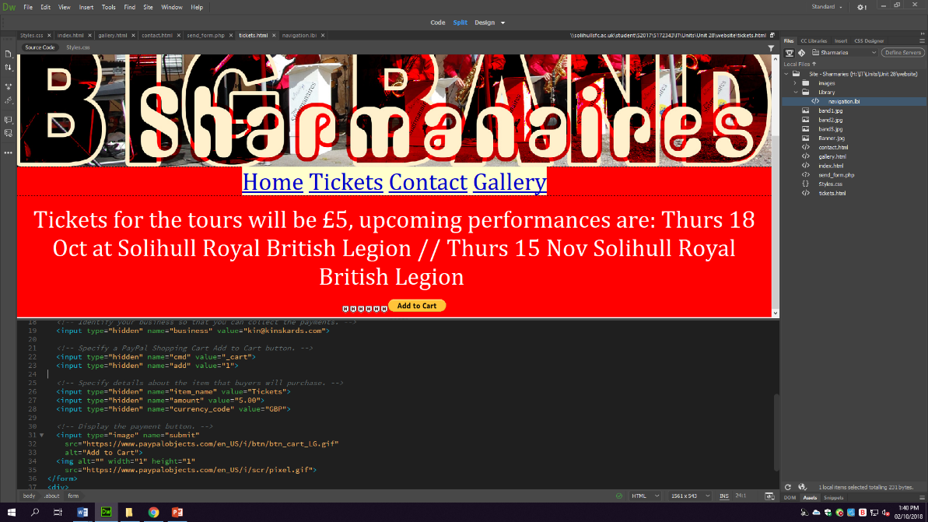Interactive features: Shopping cart

I have implemented the code for a PayPal checkout cart into my code which allows the user to purchase tickets through the secure PayPal servers, meaning that when on the tickets page they are prompted to use this basket. When clicked on, the cart will display a new tab which allows for a quantity to be selected as well as a purchasing method through PayPal accounts. I chose to use PayPal specifically due to the fact that the code was easily accessible as well as simple to put into my code after the text displayed, using PayPal over alternatives also means I will have better security when the transaction is taking place.

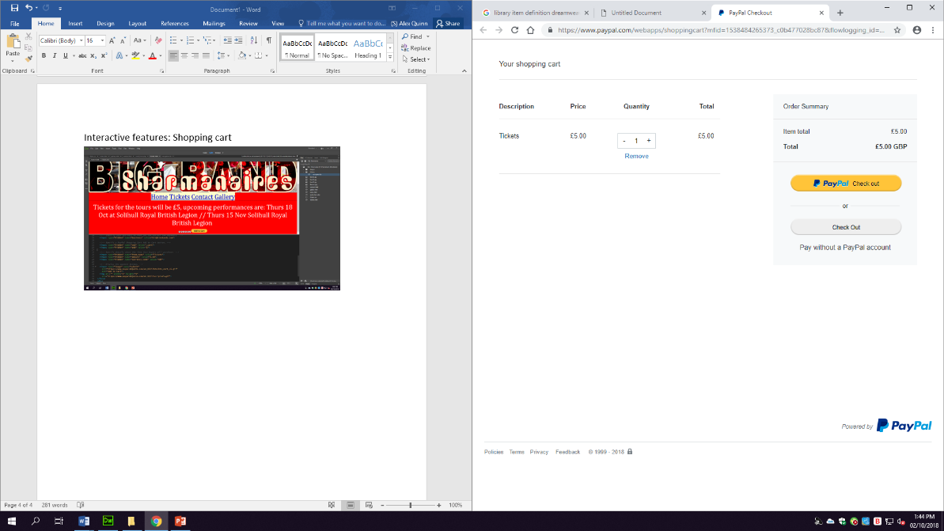

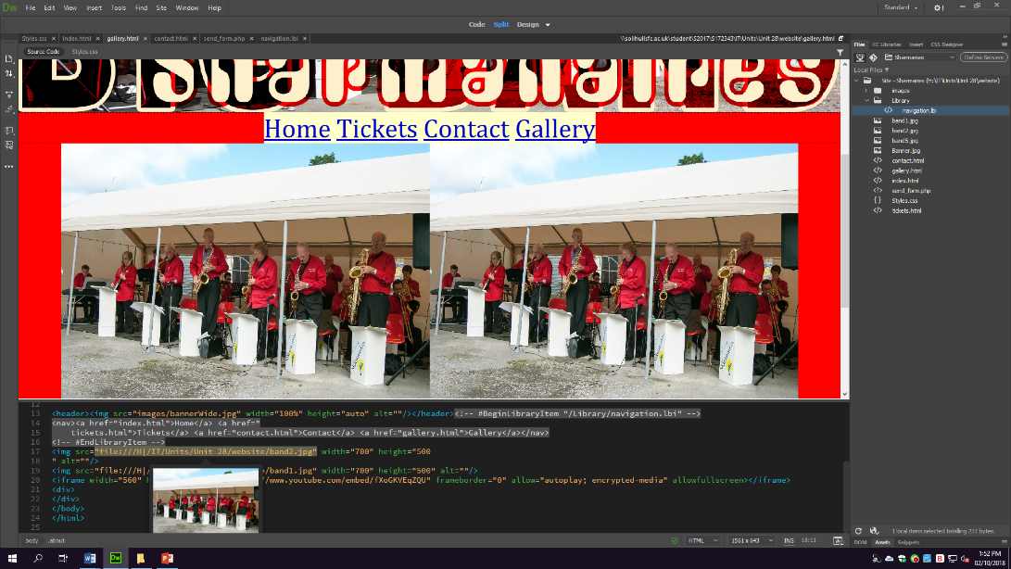Images:

I have included images within my “Gallery” page to meet the client’s needs, I did this through selecting and inserting two of the provided images into the page using the <img src=” tag while setting width to 100% and height to auto to allow the image to resize depending on which device the customer is using as well as when the tab is resized. In relation to this, I have also used the same banner throughout by inserting it into a header, although this isn’t directly within my gallery it is still an image. I have chosen to use images to make the website appeal to the user while also giving a sense of what the band stand for through the client’s needs to make sure they are fully portrayed through their website.

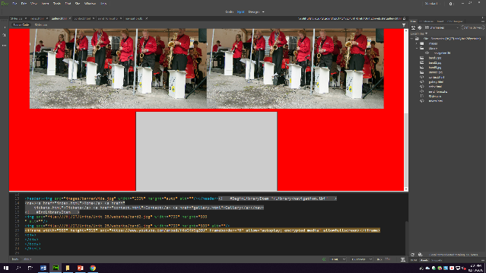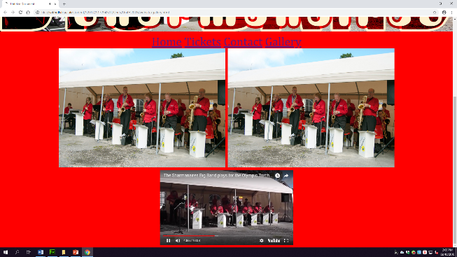Audio/Visual elements – Video and sound

To include video and audio I embedded a youtube clip from their channel to meet their specification of including past performances, through embedding the code it implements the video into the site, allowing interaction with the video as opposed to the user having to go to the actual channel through a link, I have chosen to use the embedded code due to the fact that it allows for an easy viewing of the video while also allowing the user to interact with other aspects of the page they are currently on, without having to be souly on the video to view it. This meets the client’s needs through placing the video in an easy to access way on their page, I set the images and video to a specifc size to allow for easy viewing while not being too obnoxious and filling up the whole page.

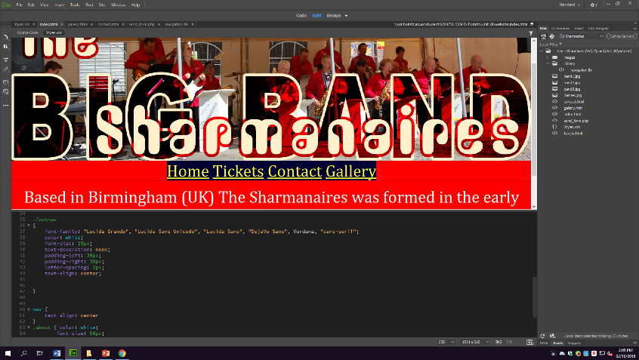Cascading style sheets:

I have used Cascading style sheets or CSS on every page to change individual items while using a style sheet of which I saved as Styles.css to correlate to the whole webpage, this allowed me to both change things on every page at once, such as the background colour while also changing specific things on each page such as centring text within one location. Within the CSS I have also defined classes for specific items within the page such as .about which allows me to set all text white, the fonts to “Cambria, "Hoefler Text", and “Liberation Serif", Times, "Times New Roman", "serif", the text centred and the font size at 50. To do this I had to link the style sheet through saving it into the same folder as my pages allowing me to apply the code to each and every page. I chose to use CSS due to the fact that it allowed me to customise each page through using classes, giving the sense of personalisation for the band’s needs.

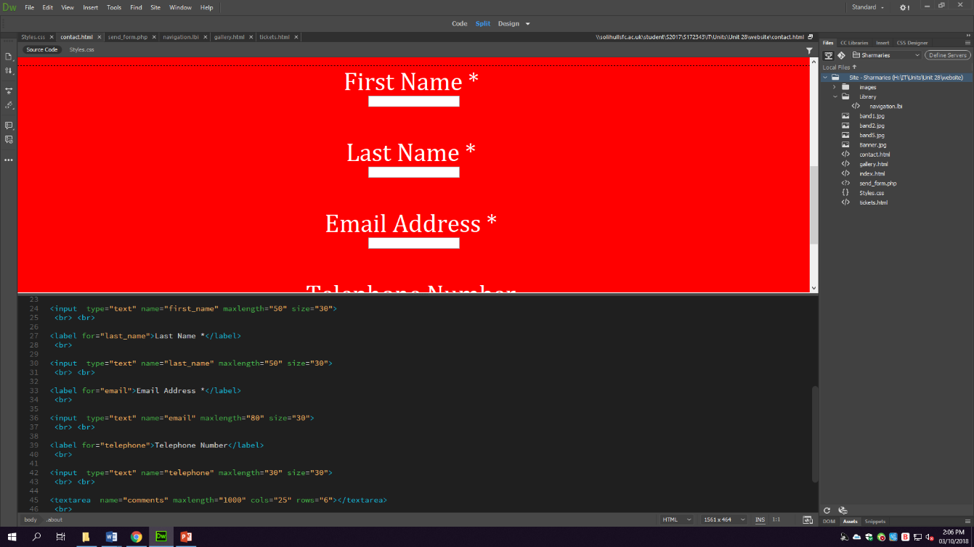Client-server scripting (Java and PHP)

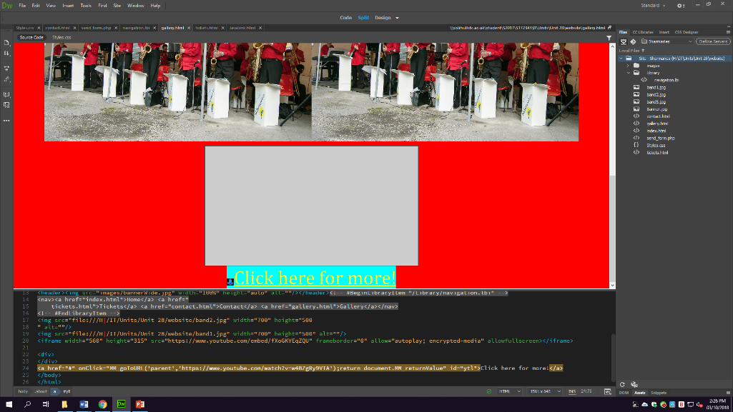I have used PHP within the contact form to allow for the interaction with the user when needing to submit a query through entering the necessary contact information, I have chosen to use PHP due to the fact that it was the easiest way to implement a contact form within my website. PHP is open source sever side scripting which helps to develop autonomous tasks, such as the contact form, due to the fact that this wouldn’t need constant monitoring or any interaction to make work, meaning I would meet the client’s needs while also meeting the user’s needs when querying something.

I have used Java script through implementing a link which redirects to another YouTube video, this allows the user to visit their page while also making the website more dynamic by allowing a redirection while using client-side scripting of which is supported by the majority of browsers. I have chosen to use Java due to the fact that it would best suit the needs to make the site slightly more dynamic and would be the best choice of programming language when making a link work to another page.

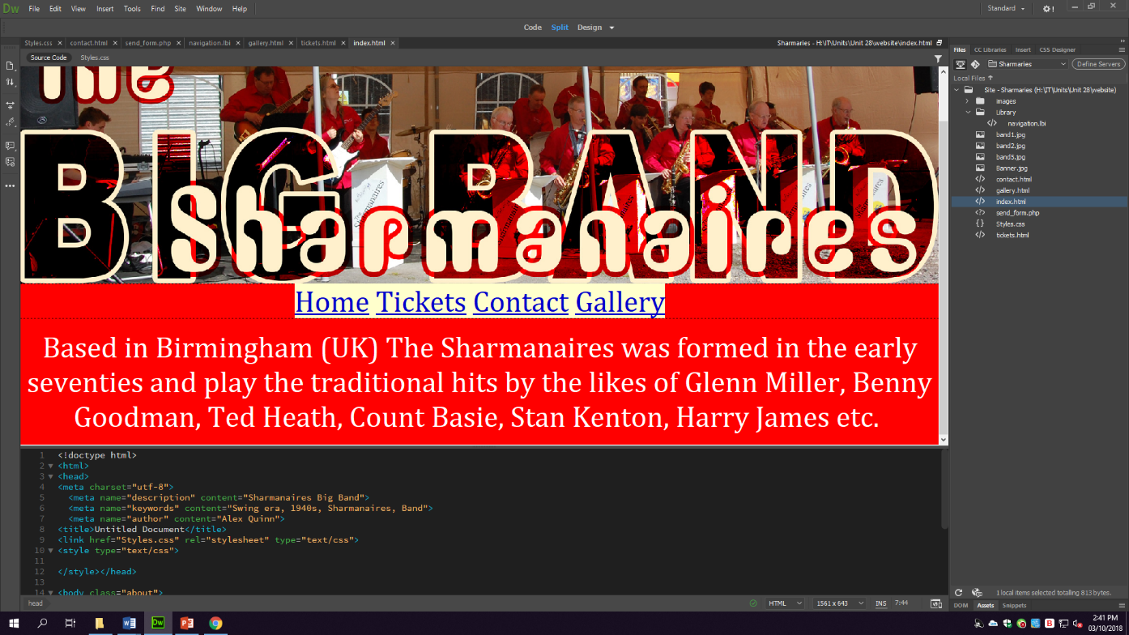Meta Tags

I have used Meta tags to allow related searches to link to the website within the search results, this would mean that people who were searching for e.g. “Swing era” would be given the option of choosing my website as their result, bringing them to the Sharmanaires page. The different types of Meta tags will show my page for different reasons, in relation to a description of the site of which the tags would be Sharmanaires big band, or for keywords of which would be, Swing era, 1920s, Sharmanaires and band while the final one would be author which would be Alex Quinn. The Meta tags allow for my page to respond and show whenever the words within the tags are typed into google, if someone was to type Sharmanaires big band my website would be one of the top results for this query.